UNIT 2 UNDERLYING LAN CONCEPTS

NETWORKS
A network is a set of devices (often referred to as nodes) connected by communication links. A node can be a computer, printer, or any other device capable of sending and/or receiving data generated by other nodes on the network.

Distributed Processing
Most networks use distributed processing, in which a task is divided among multiple computers. Instead of one single large machine being responsible for all aspects of a process, separate computers (usually a personal computer or workstation) handle a subset.

Network Criteria
A network must be able to meet a certain number of criteria. The most important of these are performance, reliability, and security.
Performance:
Performance can be measured in many ways, including transit time and response time.Transit time is the amount of time required for a message to travel from one device to another. Response time is the elapsed time between an inquiry and a response. The performance of a network depends on a number of factors, including the number of users, the type of transmission medium, the capabilities of the connected hardware, and the efficiency of the software. Performance is often evaluated by two networking metrics: throughput and delay. We often need more throughput and less delay. However, these two criteria are often contradictory. If we try to send more data to the network, we may increase throughput but we increase the delay because of traffic congestion in the network.
Reliability:
In addition to accuracy of delivery, network reliability is measured by the frequency of failure, the time it takes a link to recover from a failure, and the network's robustness in a catastrophe.
Security:
Network security issues include protecting data from unauthorized access, protecting data from damage and development, and implementing policies and procedures for recovery from breaches and data losses.

Physical Structures:
Type of Connection
A network is two or more devices connected through links. A link is a communications pathway that transfers data from one device to another. For visualization purposes, it is simplest to imagine any link as a line drawn between two points. For communication to occur, two devices must be connected in some way to the same link at the same time. There are two possible types of connections: point-to-point and multipoint.
Point-to-Point
A point-to-point connection provides a dedicated link between two devices. The entire capacity of the link is reserved for transmission between those two devices. Most point-to-point connections use an actual length of wire or cable to connect the two ends, but other options, such as microwave or satellite links, are also possible. When you change television channels by infrared remote control, you are establishing a point-to-point connection between the remote control and the television's control system.
Multipoint
A multipoint (also called multidrop) connection is one in which more than two specific devices share a single link. In a multipoint environment, the capacity of the channel is shared, either spatiallyor temporally. If several devices can use the link simultaneously, it is a spatially shared connection. If users must take turns, it is a timeshared connection.

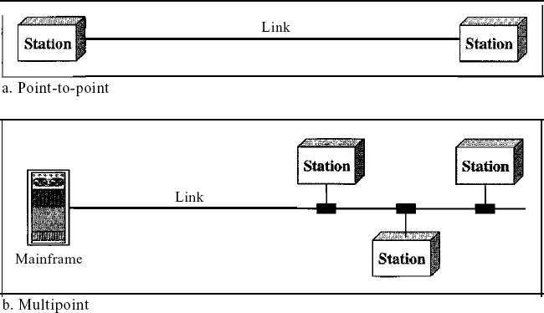
      - Physical Topology
The term physical topology refers to the way in which a network is laid out physically. One or more devices connect to a link; two or more links form a topology. The topology of a network is the geometric representation of the relationship of all the links and linking devices (usually called nodes) to one another. There are four basic topologies possible: mesh, star, bus, and ring

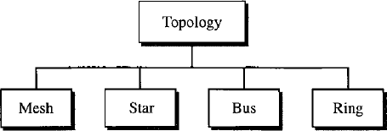

Mesh: In a mesh topology, every device has a dedicated point-to-point link to every other device. The term dedicated means that the link carries traffic only between the two devices it connects. To find the number of physical links in a fully connected mesh network with n nodes, we first consider that each node must be connected to every other node. Node 1 must be connected to n - I nodes, node 2 must be connected to n – 1 nodes, and finally node n must be connected to n - 1 nodes. We need n(n - 1) physical links. However, if each physical link allows communication in both directions (duplex mode), we can divide the number of links by 2. In other words, we can say that in a mesh topology, we need n(n -1) /2 duplex-mode links.
To accommodate that many links, every device on the network must have n – 1 input/output
(VO) ports to be connected to the other n - 1 stations.
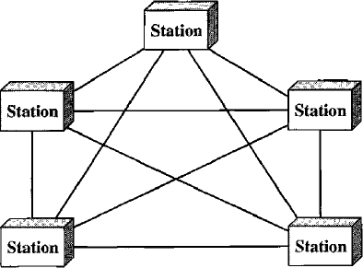
Advantages:
        - The use of dedicated links guarantees that each connection can carry its own data load, thus eliminating the traffic problems that can occur when links must be shared by multiple devices.
        - A mesh topology is robust. If one link becomes unusable, it does not incapacitate the entire system. Third, there is the advantage of privacy or security. When every message travels along a dedicated line, only the intended recipient sees it. Physical boundaries prevent other users from gaining access to messages. Finally, point-to-point links make fault identification and fault isolation easy. Traffic can be routed to avoid links with suspected problems. This facility enables the network manager to discover the precise location of the fault and aids in finding its cause and solution.
Disadvantages:
- Disadvantage of a mesh are related to the amount of cabling because every device must be connected to every other device, installation and reconnection are difficult.
- Second, the sheer bulk of the wiring can be greater than the available space (in walls, ceilings, or floors) can accommodate. Finally, the hardware required to connect each link (I/O ports and cable) can be prohibitively expensive.
For these reasons a mesh topology is usually implemented in a limited fashion, for example, as a backbone connecting the main computers of a hybrid network that can include several other topologies.

Star Topology:
In a star topology, each device has a dedicated point-to-point link only to a central controller, usually called a hub. The devices are not directly linked to one another. Unlike a mesh topology, a star topology does not allow direct traffic between devices. The controller acts as an exchange: If one device wants to send data to another, it sends the data to the controller, which then relays the data to the other connected device .
A star topology is less expensive than a mesh topology. In a star, each device needs only one link and one I/O port to connect it to any number of others. This factor also makes it easy to install and reconfigure. Far less cabling needs to be housed, and additions, moves, and deletions involve only one connection: between that device and the hub.
Other advantages include robustness. If one link fails, only that link is affected. All other links remain active. This factor also lends itself to easy fault identification and fault isolation. As long as the hub is working, it can be used to monitor link problems and bypass defective links.

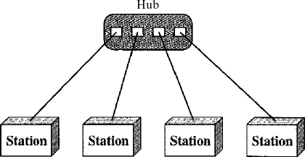

One big disadvantage of a star topology is the dependency of the whole topology on one single point, the hub. If the hub goes down, the whole system is dead. Although a star requires far less cable than a mesh, each node must be linked to a central hub. For this reason, often more cabling is required in a star than in some other topologies (such as ring or bus).

Bus Topology:
The preceding examples all describe point-to-point connections. A bus topology, on the other hand, is multipoint. One long cable acts as a backbone to link all the devices in a network
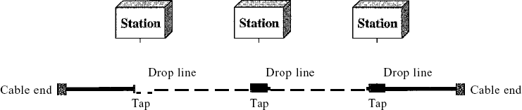
Nodes are connected to the bus cable by drop lines and taps. A drop line is a connection running between the device and the main cable. A tap is a connector that either splices into the main cable or punctures the sheathing of a cable to create a contact with the metallic core. As a signal travels along the backbone, some of its energy is transformed into heat. Therefore, it becomes weaker and weaker as it travels farther and farther. For this reason there is a limit on the number of taps a bus can support and on the distance between those taps.
Advantages of a bus topology include ease of installation. Backbone cable can be laid along the most efficient path, then connected to the nodes by drop lines of various lengths. In this way, a bus uses less cabling than mesh or star topologies. In a star, for example, four network devices in the same room require four lengths of cable reaching all the way to the hub. In a bus, this redundancy is eliminated. Only the backbone cable stretches through the entire facility. Each drop line has to reach only as far as the nearest point on the backbone.
Disadvantages include difficult reconnection and fault isolation. A bus is usually designed to be optimally efficient at installation. It can therefore be difficult to add new devices. Signal reflection at the taps can cause degradation in quality. This degradation can be controlled by limiting the number and spacing of devices connected to a given length of cable. Adding new devices may therefore require modification or replacement of the backbone.
In addition, a fault or break in the bus cable stops all transmission, even between devices on the same side of the problem. The damaged area reflects signals back in the direction of origin, creating noise in both directions.
Bus topology was the one of the first topologies used in the design of early local area networks. Ethernet LANs can use a bus topology, but they are less popular.
Ring Topology In a ring topology, each device has a dedicated point-to-point connection with only the two devices on either side of it. A signal is passed along the ring in one direction, from device to device, until it reaches its destination. Each device in the ring incorporates a repeater. When a device receives a signal intended for another device, its repeater regenerates the bits and passes them along
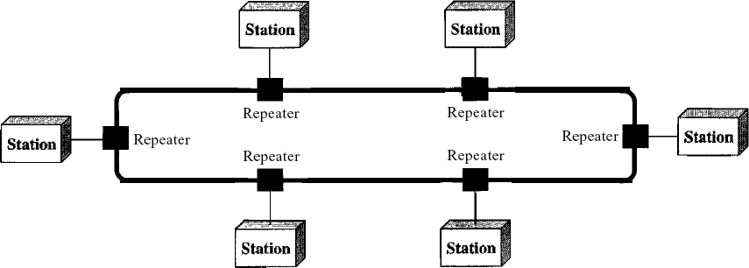
A ring is relatively easy to install and reconfigure. Each device is linked to only its immediate neighbors (either physically or logically). To add or delete a device requires changing only two connections. The only constraints are media and traffic considerations (maximum ring length and number of devices). In addition, fault isolation is simplified. Generally in a ring, a signal is circulating at all times. If one device does not receive a signal within a specified period, it can issue an alarm. The alarm alerts the network operator to the problem and its location.
However, unidirectional traffic can be a disadvantage. In a simple ring, a break in the ring (such as a disabled station) can disable the entire network. This weakness can be solved by using a dual ring or a switch capable of closing off the break. Ring topology was prevalent when IBM introduced its local-area network Token Ring. Today, the need for higher-speed LANs has made this topology less popular. Hybrid Topology A network can be hybrid. For example, we can have a main star topology with each branch connecting several stations in a bus topology as shown in Figure
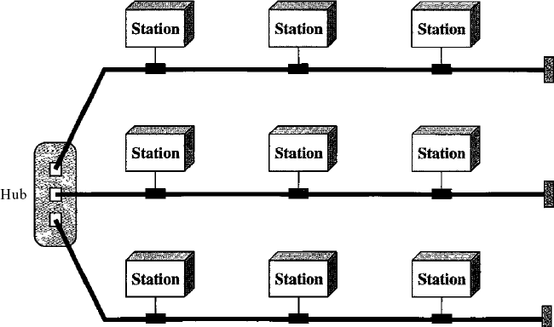

Transmission Media
For any networking to be effective, raw stream of data is to be transported from one device to other over some medium. Various transmission media can be used for transfer of data. These transmission media may be of two types −
- Guided − In guided media, transmitted data travels through cabling system that has a fixed path. For example, copper wires, fibre optic wires, etc.
- Unguided − In unguided media, transmitted data travels through free space in form of electromagnetic signal. For example, radio waves, lasers, etc.
Each transmission media has its own advantages and disadvantages in terms of bandwidth, speed, delay, cost per bit, ease of installation and maintenance, etc. Let’s discuss some of the most commonly used media in detail.

Twisted Pair Cable
Copper wires are the most common wires used for transmitting signals because of good performance at low costs. They are most commonly used in telephone lines. However, if two or more wires are lying together, they can interfere with each other’s signals. To reduce this electromagnetic interference, pair of copper wires are twisted together in helical shape like a DNA molecule. Such twisted copper wires are called twisted pair. To reduce interference between nearby twisted pairs, the twist rates are different for each pair.
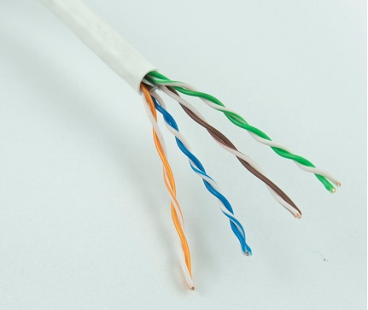
Up to 25 twisted pair are put together in a protective covering to form twisted pair cables that are the backbone of telephone systems and Ethernet networks.

Advantages of twisted pair cable
Twisted pair cable are the oldest and most popular cables all over the world. This is due to the many advantages that they offer −
- Trained personnel easily available due to shallow learning curve
- Can be used for both analog and digital transmissions
- Least expensive for short distances
- Entire network does not go down if a part of network is damaged

Disadvantages of twisted pair cable
With its many advantages, twisted pair cables offer some disadvantages too −
- Signal cannot travel long distances without repeaters
- High error rate for distances greater than 100m
- Very thin and hence breaks easily
- Not suitable for broadband connections

Shielding twisted pair cable
To counter the tendency of twisted pair cables to pick up noise signals, wires are shielded in the following three ways −
- Each twisted pair is shielded.
- Set of multiple twisted pairs in the cable is shielded.
- Each twisted pair and then all the pairs are shielded.
Such twisted pairs are called shielded twisted pair (STP) cables. The wires that are not shielded but simply bundled together in a protective sheath are called unshielded twisted pair (UTP) cables. These cables can have maximum length of 100 metres.
Shielding makes the cable bulky, so UTP are more popular than STP. UTP cables are used as the last mile network connection in homes and offices.

Coaxial Cable
Coaxial cables are copper cables with better shielding than twisted pair cables, so that transmitted signals may travel longer distances at higher speeds. A coaxial cable consists of these layers, starting from the innermost −
- Stiff copper wire as core
- Insulating material surrounding the core
- Closely woven braided mesh of conducting material surrounding the insulator
- Protective plastic sheath encasing the wire
Coaxial cables are widely used for cable TV connections and LANs.
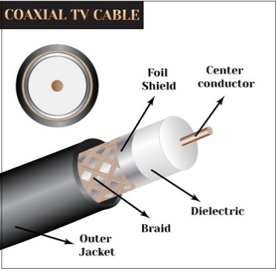

Advantages of Coaxial Cables
These are the advantages of coaxial cables −
- Excellent noise immunity
- Signals can travel longer distances at higher speeds, e.g. 1 to 2 Gbps for 1 Km cable
- Can be used for both analog and digital signals
- Inexpensive as compared to fibre optic cables
- Easy to install and maintain

Disadvantages of Coaxial Cables
These are some of the disadvantages of coaxial cables −
- Expensive as compared to twisted pair cables
- Not compatible with twisted pair cables

Optical Fibre
Thin glass or plastic threads used to transmit data using light waves are called optical fibre. Light Emitting Diodes (LEDs) or Laser Diodes (LDs) emit light waves at the source, which is read by a detector at the other end. Optical fibre cable has a bundle of such threads or fibres bundled together in a protective covering. Each fibre is made up of these three layers, starting with the innermost layer −
- Core made of high quality silica glass or plastic
- Cladding made of high quality silica glass or plastic, with a lower refractive index than the core
- Protective outer covering called buffer
Note that both core and cladding are made of similar material. However, as refractive index of the cladding is lower, any stray light wave trying to escape the core is reflected back due to total internal reflection.
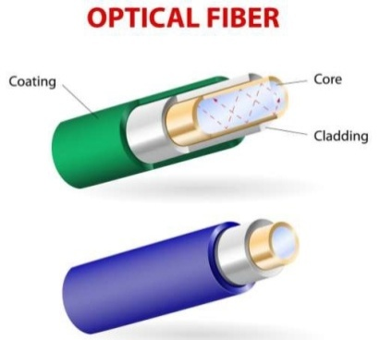
Optical fibre is rapidly replacing copper wires in telephone lines, internet communication and even cable TV connections because transmitted data can travel very long distances without weakening. Single node fibre optic cable can have maximum segment length of 2 kms and bandwidth of up to 100 Mbps. Multi-node fibre optic cable can have maximum segment length of 100 kms and bandwidth up to 2 Gbps.

Advantages of Optical Fibre
Optical fibre is fast replacing copper wires because of these advantages that it offers −
- High bandwidth
- Immune to electromagnetic interference
- Suitable for industrial and noisy areas
- Signals carrying data can travel long distances without weakening

Disadvantages of Optical Fibre
Despite long segment lengths and high bandwidth, using optical fibre may not be a viable option for every one due to these disadvantages −
- Optical fibre cables are expensive
- Sophisticated technology required for manufacturing, installing and maintaining optical fibre cables
- Light waves are unidirectional, so two frequencies are required for full duplex transmission

Infrared
Low frequency infrared waves are used for very short distance communication like TV remote, wireless speakers, automatic doors, hand held devices etc. Infrared signals can propagate within a room but cannot penetrate walls. However, due to such short range, it is considered to be one of the most secure transmission modes.
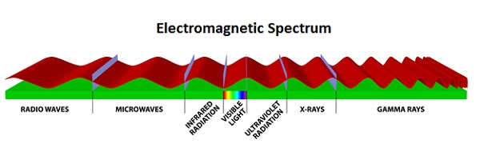

Radio Wave
Transmission of data using radio frequencies is called radio-wave transmission. We all are familiar with radio channels that broadcast entertainment programs. Radio stations transmit radio waves using transmitters, which are received by the receiver installed in our devices.
Both transmitters and receivers use antennas to radiate or capture radio signals. These radio frequencies can also be used for direct voice communication within the allocated range. This range is usually 10 miles.
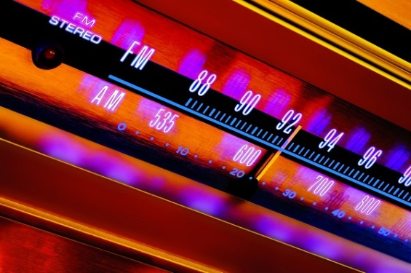

Advantages of Radio Wave
These are some of the advantages of radio wave transmissions −
- Inexpensive mode of information exchange
- No land needs to be acquired for laying cables
- Installation and maintenance of devices is cheap

Disadvantages of Radio Wave
These are some of the disadvantages of radio wave transmissions −
- Insecure communication medium
- Prone to weather changes like rain, thunderstorms, etc.

Categories of Networks

Local Area Networks:
Local area networks, generally called LANs, are privately-owned networks within a single building or campus of up to a few kilometres in size. They are widely used to connect personal computers and workstations in company offices and factories to share resources (e.g., printers) and exchange information. LANs are distinguished from other kinds of networks by three characteristics:
- Their size,
- Their transmission technology, and
- Their topology.
LANs are restricted in size, which means that the worst-case transmission time is bounded and known in advance. Knowing this bound makes it possible to use certain kinds of designs that would not otherwise be possible. It also simplifies network management. LANs may use a transmission technology consisting of a cable to which all the machines are attached, like the telephone company party lines once used in rural areas. Traditional LANs run at speeds of 10 Mbps to 100 Mbps, have low delay (microseconds or nanoseconds), and make very few errors. Newer LANs operate at up to 10 Gbps Various topologies are possible for broadcast LANs. Figure1 shows two of them. In a bus (i.e., a linear cable) network, at any instant at most one machine is the master and is allowed to transmit. All other machines are required to refrain from sending. An arbitration mechanism is needed to resolve conflicts when two or more machines want to transmit simultaneously. The arbitration mechanism may be centralized or distributed. IEEE 802.3, popularly called Ethernet, for example, is a bus-based broadcast network with decentralized control, usually operating at 10 Mbps to 10 Gbps. Computers on an Ethernet can transmit whenever they want to; if two or more packets collide, each computer just waits a random time and tries again later.
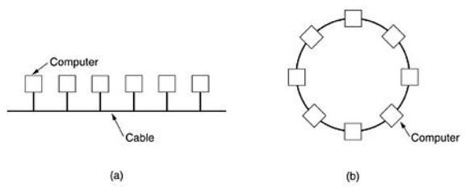

Fig.1: Two broadcast networks . (a) Bus. (b) Ring.
A second type of broadcast system is the ring. In a ring, each bit propagates around on its own, not waiting for the rest of the packet to which it belongs. Typically, each bit circumnavigates the entire ring in the time it takes to transmit a few bits, often before the complete packet has even been transmitted. As with all other broadcast systems, some rule is needed for arbitrating simultaneous accesses to the ring. Various methods, such as having the machines take turns, are in use. IEEE 802.5 (the IBM token ring), is a ring-based LAN operating at 4 and 16 Mbps. FDDI is another example of a ring network.

Metropolitan Area Network (MAN):
Metropolitan Area Network:
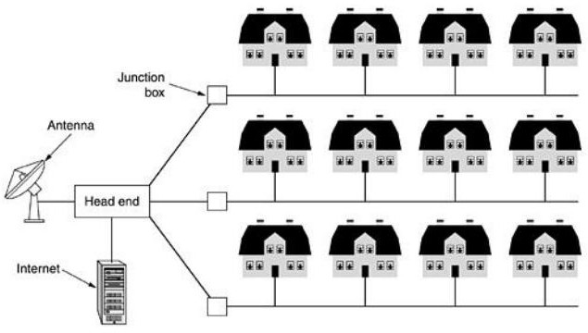
A metropolitan area network, or MAN, covers a city. The best-known example of a MAN is the cable television network available in many cities. This system grew from earlier community antenna systems used in areas with poor over-the-air television reception. In these early systems, a large antenna was placed on top of a nearby hill and signal was then piped to the subscribers' houses. At first, these were locally-designed, ad hoc systems. Then companies began jumping into the business, getting contracts from city governments to wire up an entire city. The next step was television programming and even entire channels designed for cable only. Often these channels were highly specialized, such as all news, all sports, all cooking, all gardening, and so on. But from their inception until the late 1990s, they were intended for television reception only. To a first approximation, a MAN might look something like the system shown in Fig. In this figure both television signals and Internet are fed into the centralized head end for subsequent distribution to people's homes. Cable television is not the only MAN. Recent developments in high-speed wireless Internet access resulted in another MAN, which has been standardized as IEEE 802.16.

Fig.2: Metropolitan area network based on cable TV.
A MAN is implemented by a standard called DQDB (Distributed Queue Dual Bus) or IEEE 802.16. DQDB has two unidirectional buses (or cables) to which all the computers are attached.

Wide Area Network (WAN). Wide Area Network:
A wide area network, or WAN, spans a large geographical area, often a country or continent. It contains a collection of machines intended for running user (i.e., application) programs. These machines are called as hosts. The hosts are connected by a communication subnet, or just subnet for short. The hosts are owned by the customers (e.g., people's personal computers), whereas the communication subnet is typically owned and operated by a telephone company or Internet service provider. The job of the subnet is to carry messages from host to host, just as the telephone system carries words from speaker to listener.
Separation of the pure communication aspects of the network (the subnet) from the application aspects (the hosts), greatly simplifies the complete network design. In most wide area networks, the subnet consists of two distinct components: transmission lines and switching elements. Transmission lines move bits between machines. They can be made of copper wire, optical fiber, or even radio links. In most WANs, the network contains numerous transmission lines, each one connecting a pair of routers. If two routers that do not share a transmission line wish to communicate, they must do this indirectly, via other routers. When a packet is sent from one router to another via one or more intermediate routers, the packet is received at each intermediate router in its entirety, stored there until the required output line is free, and then forwarded. A subnet organized according to this principle is called a store-and-forward or packet-switched subnet. Nearly all wide area networks (except those using satellites) have store-and-forward subnets. When the packets are small and all the same size, they are often called cells.
The principle of a packet-switched WAN is so important. Generally, when a process on some host has a message to be sent to a process on some other host, the sending host first cuts the message into packets, each one bearing its number in the sequence. These packets are then injected into the network one at a time in quick succession. The packets are transported individually over the network and deposited at the receiving host, where they are reassembled into the original message and delivered to the receiving process. A stream of packets resulting from some initial message is illustrated in Fig.
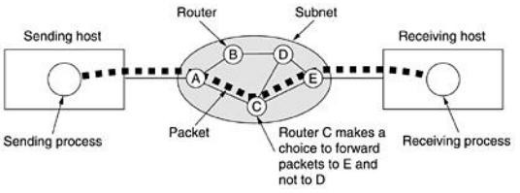
In this figure, all the packets follow the route ACE, rather than ABDE or ACDE. In some networks all packets from a given message must follow the same route; in others each packed is routed separately. Of course, if ACE is the best route, all packets may be sent along it, even if each packet is individually routed.

Fig.3.1: A stream of packets from sender to receiver.
Not all WANs are packet switched. A second possibility for a WAN is a satellite system. Each router has an antenna through which it can send and receive. All routers can hear the output from the satellite, and in some cases they can also hear the upward transmissions of their fellow routers to the satellite as well. Sometimes the routers are connected to a substantial point-to-point subnet, with only some of them having a satellite antenna. Satellite networks are inherently broadcast and are most useful when the broadcast property is important.

THE INTERNET
The Internet has revolutionized many aspects of our daily lives. It has affected the way we do business as well as the way we spend our leisure time. Count the ways you've used the Internet recently. Perhaps you've sent electronic mail (e-mail) to a business associate, paid a utility bill, read a newspaper from a distant city, or looked up a local movie schedule-all by using the Internet. Or maybe you researched a medical topic, booked a hotel reservation, chatted with a fellow Trekkie, or comparison-shopped for a car. The Internet is a communication system that has brought a wealth of information to our fingertips and organized it for our use.

A Brief History
A network is a group of connected communicating devices such as computers and printers. An internet (note the lowercase letter i) is two or more networks that can communicate with each other. The most notable internet is called the Internet (uppercase letter I), a collaboration of more than hundreds of thousands of interconnected networks. Private individuals as well as various organizations such as government agencies, schools, research facilities, corporations, and libraries in more than 100 countries use the Internet. Millions of people are users. Yet this extraordinary communication system only came into being in 1969.
In the mid-1960s, mainframe computers in research organizations were standalone devices. Computers from different manufacturers were unable to communicate with one another. The Advanced Research Projects Agency (ARPA) in the Department of Defense (DoD) was interested in finding a way to connect computers so that the researchers they funded could share their findings, thereby reducing costs and eliminating duplication of effort.
In 1967, at an Association for Computing Machinery (ACM) meeting, ARPA presented its ideas for ARPANET, a small network of connected computers. The idea was that each host computer (not necessarily from the same manufacturer) would be attached to a specialized computer, called an inteiface message processor (IMP). The IMPs, in tum, would be connected to one another. Each IMP had to be able to communicate with other IMPs as well as with its own attached host. By 1969, ARPANET was a reality. Four nodes, at the University of California at Los Angeles (UCLA), the University of California at Santa Barbara (UCSB), Stanford Research Institute (SRI), and the University of Utah, were connected via the IMPs to form a network. Software called the Network Control Protocol (NCP) provided communication between the hosts.
In 1972, Vint Cerf and Bob Kahn, both of whom were part of the core ARPANET group, collaborated on what they called the Internetting Projec1. Cerf and Kahn's landmark 1973 paper outlined the protocols to achieve end-to-end delivery of packets. This paper on Transmission Control Protocol (TCP) included concepts such as encapsulation, the datagram, and the functions of a gateway. Shortly thereafter, authorities made a decision to split TCP into two protocols: Transmission Control Protocol (TCP) and Internetworking Protocol (lP). IP would handle datagram routing while TCP would be responsible for higher-level functions such as
segmentation, reassembly, and error detection. The internetworking protocol became known as TCPIIP.

The Internet Today
The Internet has come a long way since the 1960s. The Internet today is not a simple hierarchical structure. It is made up of many wide- and local-area networks joined by connecting devices and switching stations. It is difficult to give an accurate representation of the Internet because it is continually changing-new networks are being added, existing networks are adding addresses, and networks of defunct companies are being removed. Today most end users who want Internet connection use the services of Internet service providers (lSPs). There are international service providers, national service providers, regional service providers, and local service providers. The Internet today is run by private companies, not the government. Figure 1.13 shows a conceptual (not geographic) view of the Internet.
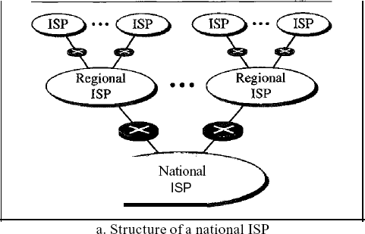
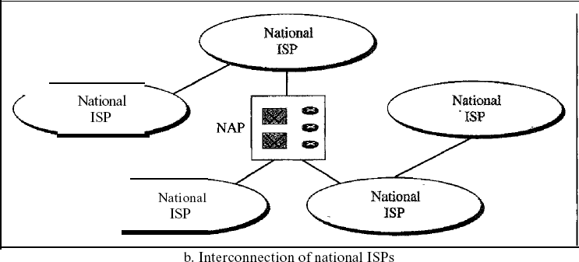

International Internet Service Providers:
At the top of the hierarchy are the international service providers that connect nations together.
National Internet Service Providers:
The national Internet service providers are backbone networks created and maintained by specialized companies. There are many national ISPs operating in North America; some of the most well known are SprintLink, PSINet, UUNet Technology, AGIS, and internet Mel. To provide connectivity between the end users, these backbone networks are connected by complex switching stations (normally run by a third party) called network access points (NAPs). Some national ISP networks are also connected to one another by private switching stations called peering points. These normally operate at a high data rate (up to 600 Mbps).
Regional Internet Service Providers:
Regional internet service providers or regional ISPs are smaller ISPs that are connected to one or more national ISPs. They are at the third level of the hierarchy with a smaller data rate. Local Internet Service Providers:
Local Internet service providers provide direct service to the end users. The local ISPs can be connected to regional ISPs or directly to national ISPs. Most end users are connected to the local ISPs. Note that in this sense, a local ISP can be a company that just provides Internet services, a corporation with a network that supplies services to its own employees, or a nonprofit organization, such as a college or a university, that runs its own network. Each of these local ISPs can be connected to a regional or national service provider.

PROTOCOLS AND STANDARDS Protocols:
In computer networks, communication occurs between entities in different systems. An entity is anything capable of sending or receiving information. However, two entities cannot simply send bit streams to each other and expect to be understood. For communication to occur, the entities must agree on a protocol. A protocol is a set of rules that govern data communications. A protocol defines what is communicated, how it is communicated, and when it is communicated. The key elements of a protocol are syntax, semantics, and timing.
    - Syntax. The term syntax refers to the structure or format of the data, meaning the order in which they are presented. For example, a simple protocol might expect the first 8 bits of data to be the address of the sender, the second 8 bits to be the address of the receiver, and the rest of the stream to be the message itself.
    - Semantics. The word semantics refers to the meaning of each section of bits. How is a particular pattern to be interpreted, and what action is to be taken based on that interpretation? For example, does an address identify the route to be taken or the final destination of the message?
    - Timing. The term timing refers to two characteristics: when data should be sent and how fast they can be sent. For example, if a sender produces data at 100 Mbps but the receiver can process data at only 1 Mbps, the transmission will overload the receiver and some data will be lost.

Standards
Standards are essential in creating and maintaining an open and competitive market for equipment manufacturers and in guaranteeing national and international interoperability of data and telecommunications technology and processes. Standards provide guidelines to manufacturers, vendors, government agencies, and other service providers to ensure the kind of interconnectivity necessary in today's marketplace and in international communications.
Data communication standards fall into two categories: de facto (meaning "by fact" or "by convention") and de jure (meaning "by law" or "by regulation").
    - De facto. Standards that have not been approved by an organized body but have been adopted as standards through widespread use are de facto standards. De facto standards are often established originally by manufacturers who seek to define the functionality of a new product or technology.
    - De jure. Those standards that have been legislated by an officially recognized body are de jure standards.

LAYERED TASKS
We use the concept of layers in our daily life. As an example, let us consider two friends who communicate through postal maiL The process of sending a letter to a friend would be complex if there were no services available from the post office. Below Figure shows the steps in this task.
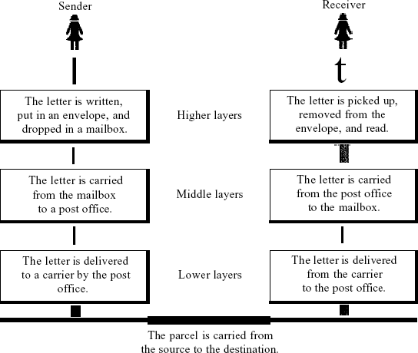
Sender, Receiver, and Carrier
In Figure we have a sender, a receiver, and a carrier that transports the letter. There is a hierarchy of tasks.
At the Sender Site
Let us first describe, in order, the activities that take place at the sender site.
- Higher layer. The sender writes the letter, inserts the letter in an envelope, writes the sender and receiver addresses, and drops the letter in a mailbox.
- Middle layer. The letter is picked up by a letter carrier and delivered to the post office.
- Lower layer. The letter is sorted at the post office; a carrier transports the letter.
0n the Way: The letter is then on its way to the recipient. On the way to the recipient's local post office, the letter may actually go through a central office. In addition, it may be transported by truck, train, airplane, boat, or a combination of these.
At the Receiver Site
- Lower layer. The carrier transports the letter to the post office.
- Middle layer. The letter is sorted and delivered to the recipient's mailbox.
- Higher layer. The receiver picks up the letter, opens the envelope, and reads it.

The OSI Reference Model:
The OSI model (minus the physical medium) is shown in Fig. This model is based on a proposal developed by the International Standards Organization (ISO) as a first step toward international standardization of the protocols used in the various layers (Day and Zimmermann, 1983). It was revised in 1995(Day, 1995). The model is called the ISO-OSI (Open Systems Interconnection) Reference Model because it deals with connecting open systems—that is, systems that are open for communication with other systems.
The OSI model has seven layers. The principles that were applied to arrive at the seven layers can be briefly summarized as follows:
- A layer should be created where a different abstraction is needed.
- Each layer should perform a well-defined function.
- The function of each layer should be chosen with an eye toward defining internationally standardized protocols.
- The layer boundaries should be chosen to minimize the information flow across the interfaces.
- The number of layers should be large enough that distinct functions need not be thrown together in the same layer out of necessity and small enough that the architecture does not become unwieldy.

The Physical Layer:
.

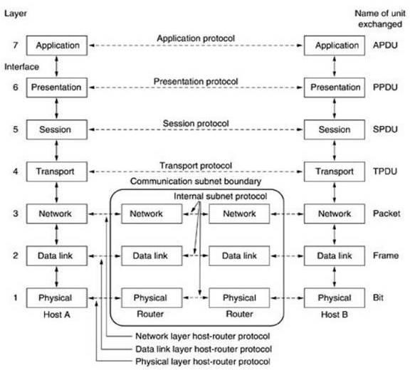
Fig.4: The OSI reference model

The physical layer is concerned with transmitting raw bits over a communication channel. The design issues have to do with making sure that when one side sends a 1 bit, it is received by the other side as a 1 bit, not as a 0 bit.

The Data Link Layer:
The main task of the data link layer is to transform a raw transmission facility into a line that appears free of undetected transmission errors to the network layer. It accomplishes this task by having the sender break up the input data into data frames (typically a few hundred or a few thousand bytes) and transmits the frames sequentially. If the service is reliable, the receiver confirms correct receipt of each frame by sending back an acknowledgement frame.
Another issue that arises in the data link layer (and most of the higher layers as well) is how to keep a fast transmitter from drowning a slow receiver in data. Some traffic regulation mechanism is often needed to let the transmitter know how much buffer space the receiver has at the moment. Frequently, this flow regulation and the error handling are integrated.

The Network Layer:
The network layer controls the operation of the subnet. A key design issue is determining how packets are routed from source to destination. Routes can be based on static tables that are ''wired into'' the network and rarely changed. They can also be determined at the start of each conversation, for example, a terminal session (e.g., a login to a remote machine). Finally, they can be highly dynamic, being determined anew for each packet, to reflect the current network load.
If too many packets are present in the subnet at the same time, they will get in one another's way, forming bottlenecks. The control of such congestion also belongs to the network layer. More generally, the quality of service provided (delay, transit time, jitter, etc.) is also a network layer issue.
When a packet has to travel from one network to another to get to its destination, many problems can arise. The addressing used by the second network may be different from the first one. The second one may not accept the packet at all because it is too large. The protocols may differ, and so on. It is up to the network layer to overcome all these problems to allow heterogeneous networks to be interconnected. In broadcast networks, the routing problem is simple, so the network layer is often thin or even nonexistent.

The Transport Layer:
The basic function of the transport layer is to accept data from above, split it up into smaller units if need be, pass these to the network layer, and ensure that the pieces all arrive correctly at the other end. Furthermore, all this must be done efficiently and in a way that isolates the upper layers from the inevitable changes in the hardware technology. The transport layer also determines what type of service to provide to the session layer, and, ultimately, to the users of the network. The most popular type of transport connection is an error-free point-to-point channel that delivers messages or bytes in the order in which they were sent. However, other possible kinds of transport service are the transporting of isolated messages, with no guarantee about the order of delivery, and the broadcasting of messages to multiple destinations. The type of service is determined when the connection is established.
The transport layer is a true end-to-end layer, all the way from the source to the destination. In other words, a program on the source machine carries on a conversation with a similar program on the destination machine, using the message headers and control messages. In the lower layers,
the protocols are between each machine and its immediate neighbours, and not between the ultimate source and destination machines, which may be separated by many routers.

The Session Layer:
The session layer allows users on different machines to establish sessions between them. Sessions offer various services, including dialog control (keeping track of whose turn it is to transmit), token management (preventing two parties from attempting the same critical operation at the same time), and synchronization (check pointing long transmissions to allow them to continue from where they were after a crash).

The Presentation Layer:
The presentation layer is concerned with the syntax and semantics of the information transmitted. In order to make it possible for computers with different data representations to communicate, the data structures to be exchanged can be defined in an abstract way, along with a standard encoding to be used ''on the wire.'' The presentation layer manages these abstract data structures and allows higher-level data structures (e.g., banking records), to be defined and exchanged.

The Application Layer:
The application layer contains a variety of protocols that are commonly needed by users. One widely-used application protocol is HTTP (Hypertext Transfer Protocol), which is the basis for the World Wide Web. When a browser wants a Web page, it sends the name of the page it wants to the server using HTTP. The server then sends the page back. Other application protocols are used for file transfer, electronic mail, and network news.

The TCP/IP Reference Model:
The TCP/IP reference model was developed prior to OSI model. The major design goals of this model were,
- To connect multiple networks together so that they appear as a single network.
- To survive after partial subnet hardware failures.
- To provide a flexible architecture.
Unlike OSI reference model, TCP/IP reference model has only 4 layers. They are,
- Host-to-Network Layer
- Internet Layer
- Transport Layer
- Application Layer Application Layer Transport Layer Internet Layer
Host-to-Network Layer

Host-to-Network Layer:
The TCP/IP reference model does not really say much about what happens here, except to point out that the host has to connect to the network using some protocol so it can send IP packets to it. This protocol is not defined and varies from host to host and network to network.

Internet Layer:
This layer, called the internet layer, is the linchpin that holds the whole architecture together. Its job is to permit hosts to inject packets into any network and have they travel independently to the destination (potentially on a different network). They may even arrive in a different order than they were sent, in which case it is the job of higher layers to rearrange them, if in-order delivery is desired. Note that ''internet'' is used here in a generic sense, even though this layer is present in the Internet.
The internet layer defines an official packet format and protocol called IP (Internet Protocol). The job of the internet layer is to deliver IP packets where they are supposed to go. Packet routing is clearly the major issue here, as is avoiding congestion. For these reasons, it is reasonable to say that the TCP/IP internet layer is similar in functionality to the OSI network layer. Fig. shows this correspondence.

The Transport Layer:
The layer above the internet layer in the TCP/IP model is now usually called the transport layer. It is designed to allow peer entities on the source and destination hosts to carry on a conversation, just as in the OSI transport layer. Two end-to-end transport protocols have been defined here. The first one, TCP (Transmission Control Protocol), is a reliable connection- oriented protocol that allows a byte stream originating on one machine to be delivered without error on any other machine in the internet. It fragments the incoming byte stream into discrete messages and passes each one on to the internet layer. At the destination, the receiving TCP process reassembles the received messages into the output stream. TCP also handles flow control
to make sure a fast sender cannot swamp a slow receiver with more messages than it can handle.
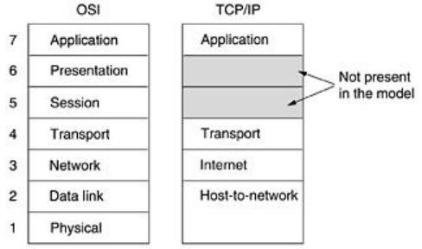

Fig.1: The TCP/IP reference model.
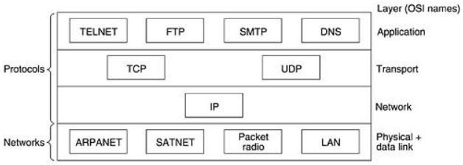
The second protocol in this layer, UDP (User Datagram Protocol), is an unreliable, connectionless protocol for applications that do not want TCP's sequencing or flow control and wish to provide their own. It is also widely used for one-shot, client-server-type request-reply queries and applications in which prompt delivery is more important than accurate delivery, such as transmitting speech or video. The relation of IP, TCP, and UDP is shown in Fig.2. Since the model was developed, IP has been implemented on many other networks.

Fig.2: Protocols and networks in the TCP/IP model initially.
The Application Layer:
The TCP/IP model does not have session or presentation layers. On top of the transport layer is the application layer. It contains all the higher-level protocols. The early ones included virtual terminal (TELNET), file transfer (FTP), and electronic mail (SMTP), as shown in Fig.6.2. The virtual terminal protocol allows a user on one machine to log onto a distant machine and work there. The file transfer protocol provides a way to move data efficiently from one machine to another. Electronic mail was originally just a kind of file transfer, but later a specialized protocol (SMTP) was developed for it. Many other protocols have been added to these over the years: the Domain Name System (DNS) for mapping host names onto their network addresses, NNTP, the protocol for moving USENET news articles around, and HTTP, the protocol for fetching pages on the World Wide Web, and many others.

Comparison of the OSI and TCP/IP Reference Models:
The OSI and TCP/IP reference models have much in common. Both are based on the concept of a stack of independent protocols. Also, the functionality of the layers is roughly similar. For example, in both models the layers up through and including the transport layer are there to provide an end-to-end, network-independent transport service to processes wishing to communicate. These layers form the transport provider. Again in both models, the layers above transport are application-oriented users of the transport service. Despite these fundamental similarities, the two models also have many differences Three concepts are central to the OSI model:
- Services.
- Interfaces.
- Protocols.
Probably the biggest contribution of the OSI model is to make the distinction between these three concepts explicit. Each layer performs some services for the layer above it. The service definition tells what the layer does, not how entities above it access it or how the layer works. It defines the layer's semantics.
A layer's interface tells the processes above it how to access it. It specifies what the parameters are and what results to expect. It, too, says nothing about how the layer works inside.
Finally, the peer protocols used in a layer are the layer's own business. It can use any protocols it wants to, as long as it gets the job done (i.e., provides the offered services). It can also change them at will without affecting software in higher layers.
The TCP/IP model did not originally clearly distinguish between service, interface, and protocol, although people have tried to retrofit it after the fact to make it more OSI-like. For example, the only real services offered by the internet layer are SEND IP PACKET and RECEIVE IP PACKET.
As a consequence, the protocols in the OSI model are better hidden than in the TCP/IP model and can be replaced relatively easily as the technology changes. Being able to make such changes is one of the main purposes of having layered protocols in the first place. The OSI reference model was devised before the corresponding protocols were invented. This ordering means that the model was not biased toward one particular set of protocols, a fact that made it quite general. The downside of this ordering is that the designers did not have much experience with the subject and did not have a good idea of which functionality to put in which layer.
Another difference is in the area of connectionless versus connection-oriented communication. The OSI model supports both connectionless and connection-oriented communication in the network layer, but only connection-oriented communication in the transport layer, where it counts (because the transport service is visible to the users). The TCP/IP model has only one mode in the network layer (connectionless) but supports both modes in the transport layer, giving the users a choice. This choice is especially important for simple request-response protocols.

Taxonomy of switched networks
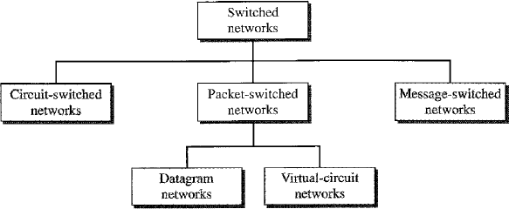

    - CIRCUIT-SWITCHED NETWORKS
A circuit-switched network consists of a set of switches connected by physical links. A connection between two stations is a dedicated path made of one or more links. However, each connection uses only one dedicated channel on each link. Each link is normally divided into n channels by using FDM or TDM
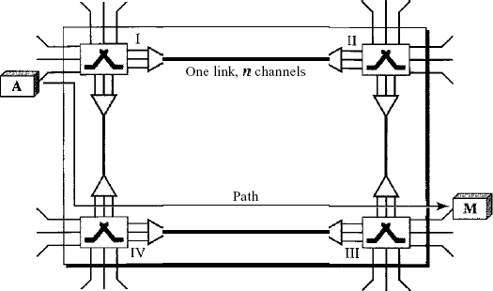
Figure shows a trivial circuit-switched network with four switches and four links. Each link is divided into n (n is 3 in the figure) channels by using FDM or TDM.

Fig: A trivial circuit-switched network
Three Phases
The actual communication in a circuit-switched network requires three phases: connection setup, data transfer, and connection teardown.

Setup Phase:
Before the two parties (or multiple parties in a conference call) can communicate, a dedicated circuit (combination of channels in links) needs to be established. The end systems are normally connected through dedicated lines to the switches, so connection setup means creating dedicated channels between the switches. For example, in Figure, when system A needs to connect to system M, it sends a setup request that includes the address of system M, to switch I. Switch I finds a channel between itself and switch IV that can be dedicated for this purpose. Switch I then sends the request to switch IV, which finds a dedicated channel between itself and switch III. Switch III informs system M of system A's intention at this time.
In the next step to making a connection, an acknowledgment from system M needs to be sent in the opposite direction to system A. Only after system A receives this acknowledgment is the connection established. Note that end-to-end addressing is required for creating a connection between the two end systems. These can be, for example, the addresses of the computers assigned by the administrator in a TDM network, or telephone numbers in an FDM network.

Data Transfer Phase:
After the establishment of the dedicated circuit (channels), the two parties can transfer
data.

Teardown Phase:
When one of the parties needs to disconnect, a signal is sent to each switch to release the resources.
Efficiency:
It can be argued that circuit-switched networks are not as efficient as the other two types of networks because resources are allocated during the entire duration of the connection. These resources are unavailable to other connections. In a telephone network, people normally terminate the communication when they have finished their conversation. However, in computer networks, a computer can be connected to another computer even if there is no activity for a long time. In this case, allowing resources to be dedicated means that other connections are deprived.
Delay
Although a circuit-switched network normally has low efficiency, the delay in this type
of network is minimal. During data transfer the data are not delayed at each switch; the resources are allocated for the duration of the connection. Figure 8.6 shows the idea of delay in a circuit- switched network when only two switches are involved. As Figure shows, there is no waiting time at each switch. The total delay is due to the time needed to create the connection, transfer data, and disconnect the circuit.
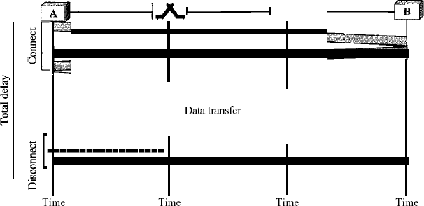

Fig: Delay in a circuit-switched network
The delay caused by the setup is the sum of four parts: the propagation time of the source computer request (slope of the first gray box), the request signal transfer time (height of the first gray box), the propagation time of the acknowledgment from the destination computer (slope of the second gray box), and the signal transfer time of the acknowledgment (height of the second gray box). The delay due to data transfer is the sum of two parts: the propagation time (slope of the colored box) and data transfer time (height of the colored box), which can be very long. The third box shows the time needed to tear down the circuit. We have shown the case in which the receiver requests disconnection, which creates the maximum delay.

DATAGRAM NETWORKS
In a datagram network, each packet is treated independently of all others. Even if a packet is part of a multipacket transmission, the network treats it as though it existed alone. Packets in this approach are referred to as datagrams.
Datagram switching is normally done at the network layer. We briefly discuss datagram networks here as a comparison with circuit-switched and virtual-circuit switched networks Figure shows how the datagram approach is used to deliver four packets from station A to station
X. The switches in a datagram network are traditionally referred to as routers. That is why we use a different symbol for the switches in the figure.
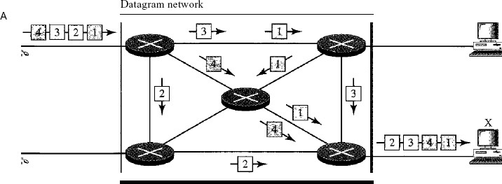

Fig: A datagram network with four switches (routers)
In this example, all four packets (or datagrams) belong to the same message, but may travel different paths to reach their destination. This is so because the links may be involved in carrying packets from other sources and do not have the necessary bandwidth available to carry all the packets from A to X. This approach can cause the datagrams of a transmission to arrive at their destination out of order with different delays between the packets. Packets may also be lost or dropped because of a lack of resources. In most protocols, it is the responsibility of an upper- layer protocol to reorder the datagrams or ask for lost datagrams before passing them on to the application.
The datagram networks are sometimes referred to as connectionless networks. The term connectionless here means that the switch (packet switch) does not keep information about the connection state. There are no setup or teardown phases. Each packet is treated the same by a switch regardless of its source or destination.
Routing Table
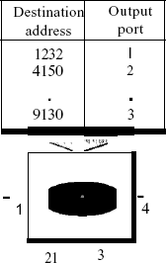
If there are no setup or teardown phases, how are the packets routed to their destinations in a datagram network? In this type of network, each switch (or packet switch) has a routing table which is based on the destination address. The routing tables are dynamic and are updated periodically. The destination addresses and the corresponding forwarding output ports are recorded in the tables. This is different from the table of a circuit switched network in which each entry is created when the setup phase is completed and deleted when the teardown phase is over. Figure shows the routing table for a switch.

Destination Address
Fig: Routing table in a datagram network

Every packet in a datagram network carries a header that contains, among other information, the destination address of the packet. When the switch receives the packet, this destination address is examined; the routing table is consulted to find the corresponding port through which the packet should be forwarded. This address, unlike the address in a virtual- circuit-switched network, remains the same during the entire journey of the packet.

Efficiency
The efficiency of a datagram network is better than that of a circuit-switched network; resources are allocated only when there are packets to be transferred. If a source sends a packet and there is a delay of a few minutes before another packet can be sent, the resources can be reallocated during these minutes for other packets from other sources.

Delay
There may be greater delay in a datagram network than in a virtual-circuit network. Although there are no setup and teardown phases, each packet may experience a wait at a switch before it is forwarded. In addition, since not all packets in a message necessarily travel through the same switches, the delay is not uniform for the packets of a message.
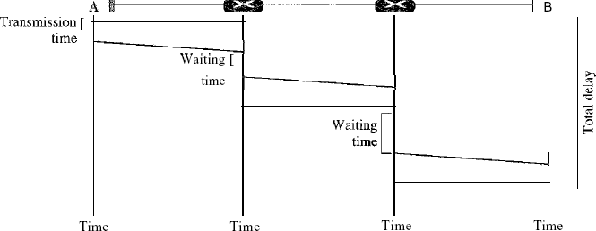

Fig: Delay in a datagram network
The packet travels through two switches. There are three transmission times (3T), three propagation delays (slopes 3't of the lines), and two waiting times (WI + w2)' We ignore the processing time in each switch. The total delay is
Total delay =3T + 3t + WI + W2

VIRTUAL-CIRCUIT NETWORKS:
A virtual-circuit network is a cross between a circuit-switched network and a datagram network. It has some characteristics of both.
- As in a circuit-switched network, there are setup and teardown phases in addition to the data transfer phase.
- Resources can be allocated during the setup phase, as in a circuit-switched network, or on demand, as in a datagram network.
- As in a datagram network, data are packetized and each packet carries an address in the header. However, the address in the header has local jurisdiction (it defines what should be the next switch and the channel on which the packet is being canied), not end-to-end jurisdiction. The reader may ask how the intermediate switches know where to send the packet if there is no
final destination address carried by a packet. The answer will be clear when we discuss virtual- circuit identifiers in the next section.
- As in a circuit-switched network, all packets follow the same path established during the connection.
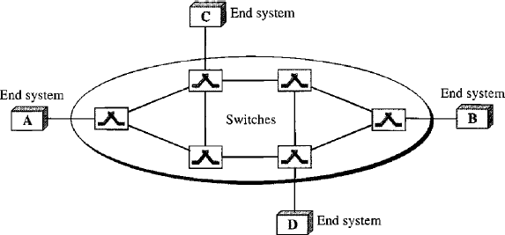
- A virtual-circuit network is normally implemented in the data link layer, while a circuit- switched network is implemented in the physical layer and a datagram network in the network layer. But this may change in the future. Figure is an example of a virtual-circuit network. The network has switches that allow traffic from sources to destinations. A source or destination can be a computer, packet switch, bridge, or any other device that connects other networks.

Addressing
Fig a: Virtual-circuit network

In a virtual-circuit network, two types of addressing are involved: global and local (virtual-circuit identifier).
Global Addressing: A source or a destination needs to have a global address-an address that can be unique in the scope of the network or internationally if the network is part of an international network. However, we will see that a global address in virtual-circuit networks is used only to create a virtual-circuit identifier, as discussed next.
Virtual-Circuit Identifier: The identifier that is actually used for data transfer is called the virtual-circuit identifier (Vel). A vel, unlike a global address, is a small number that has only switch scope; it is used by a frame between two switches. When a frame arrives at a switch, it has a VCI; when it leaves, it has a different VCl. Figure 8.11 shows how the VCI in a data frame

changes from one switch to another. Note that a VCI does not need to be a large number since each switch can use its own unique set of VCls.
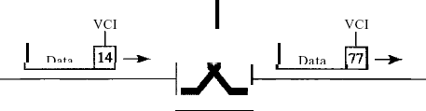

Figure 1 Virtual-circuit identifier
Three Phases
As in a circuit-switched network, a source and destination need to go through three phases in a virtual-circuit network: setup, data transfer, and teardown. In the setup phase, the source and destination use their global addresses to help switches make table entries for the connection. In the teardown phase, the source and destination inform the switches to delete the corresponding entry. Data transfer occurs between these two phases. We first discuss the data transfer phase, which is more straightforward; we then talk about the setup and teardown phases.
Data Transfer Phase
To transfer a frame from a source to its destination, all switches need to have a table entry for this virtual circuit. The table, in its simplest form, has four columns. This means that the switch holds four pieces of information for each virtual circuit that is already set up. We show later how the switches make their table entries, but for the moment we assume that each switch has a table with entries for all active virtual circuits. Figure 2 shows such a switch and its corresponding table. And also shows a frame arriving at port 1 with a VCI of 14. When the frame arrives, the switch looks in its table to find port 1 and a VCI of 14. When it is found, the switch knows to change the VCI to 22 and send out the frame from port 3. Figure 3 shows how a frame from source A reaches destination B and how its VCI changes during the trip. Each switch changes the VCI and routes the frame. The data transfer phase is active until the source sends all its frames to the destination. The procedure at the switch is the same for each frame of a message. The process creates a virtual circuit, not a real circuit, between the source and destination.
Setup Phase
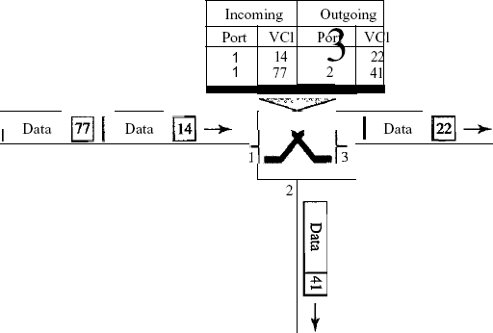
In the setup phase, a switch creates an entry for a virtual circuit. For example, suppose source A needs to create a virtual circuit to B. Two steps are required: the setup request and the acknowledgment.
Figure 2 Switch and tables in a virtual-circuit network
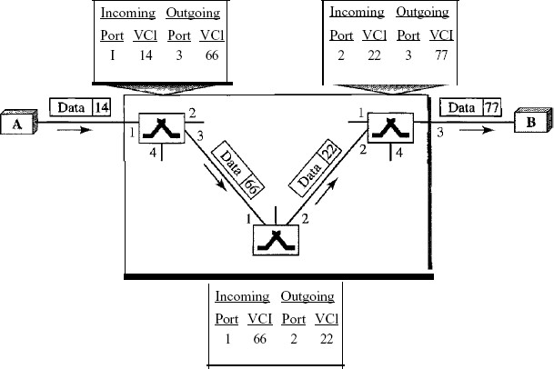

Figure 3 Source-to-destination data transfer in a virtual-circuit network
Setup Request
A setup request frame is sent from the source to the destination. Figure 4 shows the process.
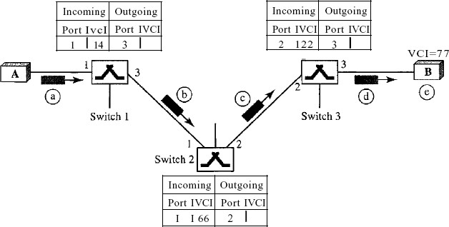

Figure 4 Setup request in a virtual-circuit network
  - Source A sends a setup frame to switch 1.
  - Switch 1 receives the setup request frame. It knows that a frame going from A to B goes out through port 3. How the switch has obtained this information is a point covered in future chapters. The switch, in the setup phase, acts as a packet switch; it has a routing table which is different from the switching table. For the moment, assume that it knows the output port. The switch creates an entry in its table for this virtual circuit, but it is only able to fill three of the four columns. The switch assigns the incoming port (1) and chooses an available incoming VCI (14) and the outgoing port (3). It does not yet know the outgoing VCI, which will be found during
the acknowledgment step. The switch then forwards the frame through port 3 to switch 2.
  - Switch 2 receives the setup request frame. The same events happen here as at switch 1; three columns of the table are completed: in this case, incoming port (l), incoming VCI (66), and outgoing port (2).
  - Switch 3 receives the setup request frame. Again, three columns are completed: incoming port (2), incoming VCI (22), and outgoing port (3).
  - Destination B receives the setup frame, and if it is ready to receive frames from A, it assigns a VCI to the incoming frames that come from A, in this case 77. This VCI lets the destination know that the frames come from A, and not other sources.

Acknowledgment A special frame, called the acknowledgment frame, completes the entries in the switching tables. Figure 8.15 shows the process.
- The destination sends an acknowledgment to switch 3. The acknowledgment carries the global source and destination addresses so the switch knows which entry in the table is to be completed. The frame also carries VCI 77, chosen by the destination as the incoming VCI for frames from
A. Switch 3 uses this VCI to complete the outgoing VCI column for this entry. Note that 77 is the incoming VCI for destination B, but the outgoing VCI for switch 3.
- Switch 3 sends an acknowledgment to switch 2 that contains its incoming VCI in the table, chosen in the previous step. Switch 2 uses this as the outgoing VCI in the table.
- Switch 2 sends an acknowledgment to switch 1 that contains its incoming VCI in the table, chosen in the previous step. Switch 1 uses this as the outgoing VCI in the table.
- Finally switch 1 sends an acknowledgment to source A that contains its incoming VCI in the table, chosen in the previous step.
- The source uses this as the outgoing VCI for the data frames to be sent to destination B.

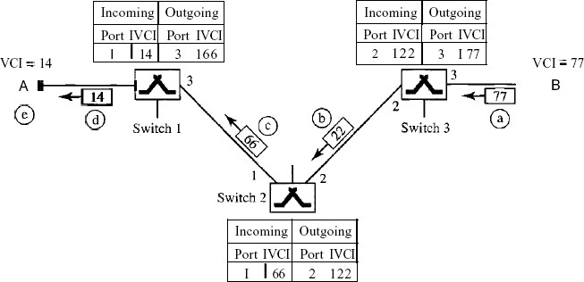

Figure 5 Setup acknowledgments in a virtual-circuit network
Teardown Phase
In this phase, source A, after sending all frames to B, sends a special frame called a teardown request. Destination B responds with a teardown confirmation frame. All switches delete the corresponding entry from their tables.

Efficiency
As we said before, resource reservation in a virtual-circuit network can be made during the setup or can be on demand during the data transfer phase. In the first case, the delay for each packet is the same; in the second case, each packet may encounter different delays. There is one big advantage in a virtual-circuit network even if resource allocation is on demand. The source can check the availability of the resources, without actually reserving it. Consider a family that wants to dine at a restaurant. Although the restaurant may not accept reservations (allocation of the tables is on demand), the family can call and find out the waiting time. This can save the family time and effort.

Delay in Virtual-Circuit Networks
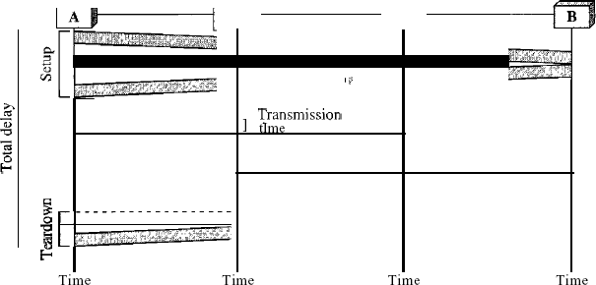
In a virtual-circuit network, there is a one-time delay for setup and a one-time delay for teardown. If resources are allocated during the setup phase, there is no wait time for individual packets. Below Figure shows the delay for a packet traveling through two switches in a virtual- circuit network.

Fig: Delay in a virtual-circuit network
The packet is traveling through two switches (routers). There are three transmission times (3T), three propagation times (3't), data transfer depicted by the sloping lines, a setup delay (which includes transmission and propagation in two directions), and a teardown delay (which includes transmission and propagation in one direction). We ignore the processing time in each switch. The total delay time is
Total delay = 3T+ 3't + setup delay + teardown delay

  - Framing:

.

UNIT – V

Random Access:

UNIT-6
  - IEEE STANDARDS
In 1985, the Computer Society of the IEEE started a project, called Project 802, to set standards to enable intercommunication among equipment from a variety of manufacturers. Project 802 does not seek to replace any part of the OSI or the Internet model. Instead, it is a way of specifying functions of the physical layer and the data link layer of major LAN protocols.
The standard was adopted by the American National Standards Institute (ANSI). In 1987, the International Organization for Standardization (ISO) also approved it as an international standard under the designation ISO 8802. The relationship of the 802 Standard to the traditional OSI model is shown in Figure 1.
The IEEE has subdivided the data link layer into two sublayers: logical link control (LLC) and media access control (MAC).
IEEE has also created several physical layer standards for different LAN protocols.
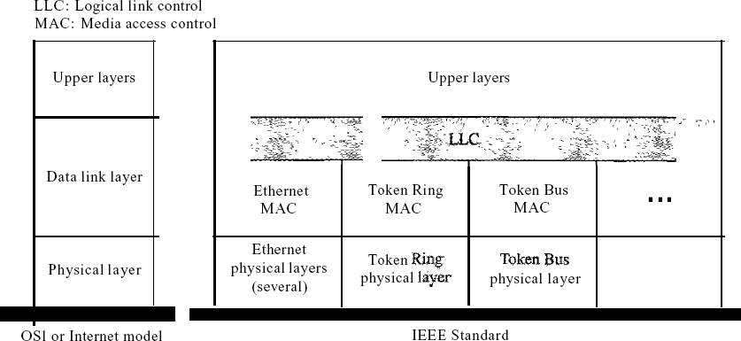

Figure 1 IEEE standardfor LANs
    - Data Link Layer
As we mentioned before, the data link layer in the IEEE standard is divided into two sublayers: LLC and MAC.
Logical Link Control (LLC)
We said that data link control handles framing, flow control, and error control. In IEEE Project 802, flow control, error control,and part of the framing duties are collected into one sublayer called the logical link control. Framing is handled in both the LLC sublayer and the MAC sublayer.
The LLC provides one single data link control protocol for all IEEE LANs. In this way, the LLC is different from the media access control sublayer, which provides different protocols for different LANs. A single LLC protocol can provide interconnectivity between different LANs because it makes the MAC sublayer transparent. Figure 1 shows one single LLC protocol serving several MAC protocols. Framing LLC defines a protocol data unit (PDU) that is somewhat similar to that of HDLC. The header contains a control field like the one in HDLC; this field is used for flow and error control. The two other header fields define the upper-layer protocol at the source and destination that uses LLC. These fields are called the destination service access point (DSAP) and the source service access point (SSAP). The other fields defined in a typical data link control protocol such as HDLC are moved to the MAC sublayer. In other words, a frame defined in HDLC is divided into a PDU at the LLC sublayer and a frame at the MAC sublayer, as shown in Figure 2.
Need for LLC The purpose of the LLC is to provide flow and error control for the upper-layer protocols that actually demand these services. For example, if a LAN or several LANs are used in an isolated system, LLC may be needed to provide flow and error control for the application layer protocols. However, most upper-layer protocols such as IP, do not use the services of LLC.

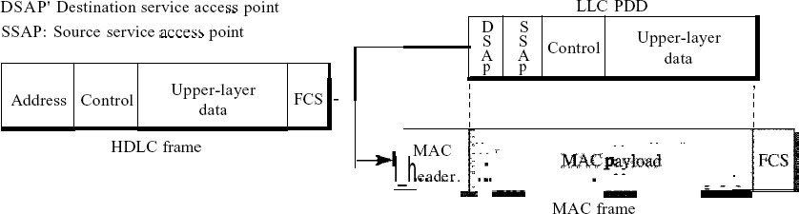

Figure 13.2 HDLCframe compared with LLC and MAC frames
Media Access Control (MAC)
IEEE Project 802 has created a sublayer called media access control that defines the specific access method for each LAN. For example, it defines CSMA/CD as the media access method for Ethernet LANs and the tokenpassing method for Token Ring and Token Bus LANs. As we discussed in the previous section, part of the framing function is also handled by the MAC layer. In contrast to the LLC sublayer, the MAC sublayer contains a number of distinct modules; each defines the access method and the framing format specific to the corresponding LAN protocol.

Physical Layer
The physical layer is dependent on the implementation and type of physical media used. IEEE defines detailed specifications for each LAN implementation. For example, although there is only one MAC sublayer for Standard Ethernet, there is a different physical layer specifications for each Ethernet implementations.

Standard Ethernet
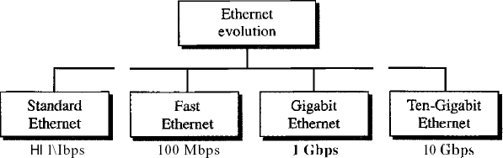

Figure 3 Ethernet evolution through four generations

MAC Sublayer
In Standard Ethernet, the MAC sublayer governs the operation of the access method. It also frames data received from the upper layer and passes them to the physical layer.
Frame Format
The Ethernet frame contains seven fields: preamble, SFD, DA, SA, length or type of protocol data unit (PDU), upper-layer data, and the CRe. Ethernet does not provide any mechanism for acknowledging received frames, making it what is known as an unreliable medium.
Acknowledgments must be implemented at the higher layers. The format ofthe MAC frame is shown in Figure 4.
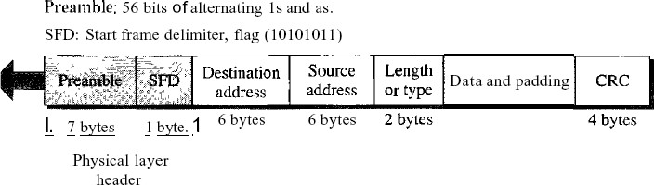
Figure 4 802.3 MACframe

 D Preamble. The first field of the 802.3 frame contains 7 bytes (56 bits) of alternating Os and Is that alerts the receiving system to the coming frame and enables it to synchronize its input timing. The pattern provides only an alert and a timing pulse. The 56-bit pattern allows the stations to miss some bits at the beginning of the frame. The preamble is actually added at the physical layer and is not (formally) part of the frame.
D Start frame delimiter (SFD). The second field (l byte: 10101011) signals the beginning of the frame. The SFD warns the station or stations that this is the last chance for synchronization. The last 2 bits is 11 and alerts the receiver that the next field is the destination address.
Destination address (DA). The DA field is 6 bytes and contains the physical address of the destination station or stations to receive the packet.
Source address (SA). The SA field is also 6 bytes and contains the physical address of the sender of the packet. We will discuss addressing shortly.
Length or type. This field is defined as a type field or length field. The original Ethernet used this field as the type field to define the upper-layer protocol using the MAC frame. The IEEE standard used it as the length field to define the number of bytes in the data field. Both uses are common today.

Data. This field carries data encapsulated from the upper-layer protocols. It is a minimum of 46 and a maximum of 1500 bytes.
CRC. The last field contains error detection information, in this case a CRC-32
Frame Length
Ethernet has imposed restrictions on both the minimum and maximum lengths of a frame, as shown in Figure 5.
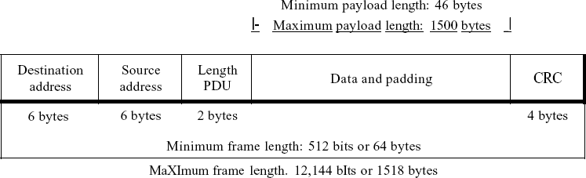

Figure 5 Minimum and maximum lengths

The minimum length restriction is required for the correct operation of CSMAlCD. An Ethernet frame needs to have a minimum length of 512 bits or 64 bytes. Part of this length is the header and the trailer. If we count 18 bytes of header and trailer (6 bytes of source address, 6 bytes of destination address, 2 bytes of length or type, and 4 bytes of CRC), then the minimum length of data from the upper layer is 64 - 18 = 46 bytes. If the upper-layer packet is less than 46 bytes, padding is added to make up the difference.
The standard defines the maximum length of a frame (without preamble and SFD field) as 1518 bytes. If we subtract the 18 bytes of header and trailer, the maximum length of the payload is 1500 bytes. The maximum length restriction has two historical reasons. First, memory was very expensive when Ethernet was designed: a maximum length restriction helped to reduce the size of the buffer. Second, the maximum length restriction prevents one station from monopolizing the shared medium, blocking other stations that have data to send.
Frame length:
Minimum: 64 bytes (512 bits) Maximum: 1518 bytes (12,144 bits)

Addressing
Each station on an Ethernet network (such as a PC, workstation, or printer) has its own network interface card (NIC). The NIC fits inside the station and provides the station with a 6-byte
physical address. As shown in Figure 6, the Ethernet address is 6 bytes (48 bits), nonnally written in hexadecimal notation, with a colon between the bytes.
06:01 :02:01:2C:4B
6 bytes =12 hex digits =48 bits

Figure 6 Example ofan Ethernet address in hexadecimal notation

Unicast, Multicast, and Broadcast Addresses A source address is always a unicast address-the frame comes from only one station. The destination address, however, can be unicast, multicast, or broadcast. Figure 7 shows how to distinguish a unicast address from a multicast address. If the least significant bit of the first byte in a destination address is 0, the address is unicast; otherwise, it is multicast.
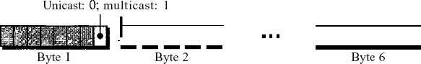

Figure 7 Unicast and multicast addresses

A unicast destination address defines only one recipient; the relationship between the sender and the receiver is one-to-one. A multicast destination address defines a group of addresses; the relationship between the sender and the receivers is one-to-many. The broadcast address is a special case of the multicast address; the recipients are all the stations on the LAN. A broadcast destination address is forty-eight.
    - Physical Layer
The Standard Ethernet defines several physical layer implementations; four of the most common, are shown in Figure 8.
Encoding and Decoding
All standard implementations use digital signaling (baseband) at 10 Mbps. At the sender, data are converted to a digital signal using the Manchester scheme; at the receiver, the received signal is interpreted as Manchester and decoded into data. Manchester encoding is self-synchronous, providing a transition at each bit interval. Figure 9 shows the encoding scheme for Standard Ethernet.

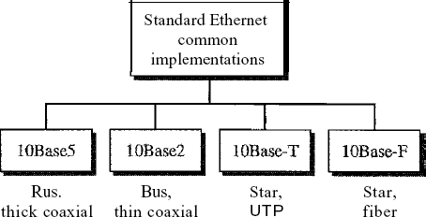

Figure 8 Categories ofStandard Ethernet

Fast Ethernet
Fast Ethernet was designed to compete with LAN protocols such as FDDI or Fiber Channel (or Fibre Channel, as it is sometimes spelled). IEEE created Fast Ethernet under the name 802.3u. Fast Ethernet is backward-compatible with Standard Ethernet, but it can transmit data 10 times faster at a rate of 100 Mbps.
The goals of Fast Ethernet can besummarized as follows:
- Upgrade the data rate to 100 Mbps.
- Make it compatible with Standard Ethernet.
- Keep the same 48-bit address.
- Keep the same frame format.
- Keep the same minimum and maximum frame lengths.

MAC Sublayer Physical Layer

6.4 IEEE 802.11
6.4.1 Architecture
The standard defines two kinds of services: the basic service set (BSS) and the extended service set (ESS).
Basic Service Set
IEEE 802.11 defines the basic service set (BSS) as the building block of a wireless LAN. A basic service set is made of stationary or mobile wireless stations and an optional central base station, known as the access point (AP). Figure 9 shows two sets in this standard.
The BSS without anAP is a stand-alone network and cannot send data to other BSSs. It is called an ad hoc architecture. In this architecture, stations can form a network without the need of an
AP; they can locate one another and agree to be part of a BSS. A BSS with an AP is sometimes referred to as an infrastructure network.
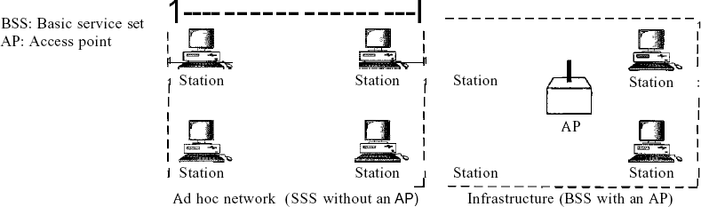

Figure. 9 Basic service sets (BSSs)
Extended Service Set
An extended service set (ESS) is made up of two or more BSSs with APs. In this case, the BSSs are connected through a distribution system, which is usually a wired LAN. The distribution system connects the APs in the BSSs. IEEE 802.11 does not restrict the distribution system; it can be any IEEE LAN such as an Ethernet. Note that the extended service set uses two types of stations: mobile and stationary. The mobile stations are normal stations inside a BSS. The stationary stations are AP stations that are part of a wired LAN. Figure 10 shows an ESS.
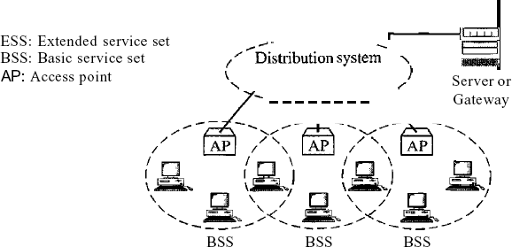
Figure 10 Extended service sets (ESSs)

Token Ring (IEEE 802.5)

Token Ring: A Brief History

Originally, IBM developed Token Ring network in the 1970s. It is still IBM's primary local-area network (LAN) technology. The related IEEE 802.5 specification is almost identical to and completely compatible with IBM's Token Ring network. In fact, the IEEE 802.5 specification was modeled after IBM Token Ring, and on the same lines. The term Token Ring is generally used to refer to both IBM's Token Ring network and IEEE
802.5 networks.

Introduction
Before going into the details of the Token Ring protocol, let’s first discuss the motivation behind it. As already discussed, the medium access mechanism used by Ethernet (CSMA/CD) may results in collision. Nodes attempt to a number of times before they can actually transmit, and even when they start transmitting there are chances to encounter collisions and entire transmission need to be repeated. And all this become worse one the traffic is heavy i.e. all nodes have some data to transmit. Apart from this there is no way to predict either the occurrence of collision or delays produced by multiple stations attempting to capture the link at the same time. So all these problems with the Ethernet gives way to an alternate LAN technology, Token Ring.

Token Ring and IEEE802.5 are based on token passing MAC protocol with ring topology. They resolve the uncertainty by giving each station a turn on by one. Each node takes turns sending the data; each station may transmit data during its turn. The technique that coordinates this turn mechanism is called Token passing; as a Token is passed in the network and the station that gets the token can only transmit. As one node transmits at a time, there is no chance of collision. We shall discuss the detailed operation in next section.

Stations are connected by point-to-point links using repeaters. Mainly these links are of shielded twisted-pair cables. The repeaters function in two basic modes: Listen mode, Transmit mode. A disadvantage of this topology is that it is vulnerable to link or station failure. But a few measures can be taken to take care of it.

Differences between Token Ring and IEEE 802.5

Both of these networks are basically compatible, although the specifications differ in some ways.
- IEEE 802.5 does not specify a topology, although virtually all IEEE 802.5 implementations are based on the star topology. While IBM's Token Ring network explicitly specifies a star, with all end stations attached to a device called a Multi- Station Access Unit (MSAU).
- IEEE 802.5 does not specify a media type, although IBM Token Ring networks use twisted-pair wire.
- There are few differences in routing information field size of the two.

Token Ring Operation
Token-passing networks move a small frame, called a token, around the network. Possession of the token grants the right to transmit. If a node receiving the token has no information to send, it passes the token to the next end station. Each station can hold the token for a maximum period of time.
If a station possessing the token does have information to transmit, it seizes the token, alters 1 bit of the token (which turns the token into a start-of-frame sequence), appends the information that it wants to transmit, and sends this information to the next station on the ring. While the information frame is circling the ring, no token is on the network (unless the ring supports early token release), which means that other stations wanting to transmit must wait. Therefore, collisions cannot occur in Token Ring networks. If early token release is supported, a new token can be released immediately after a frame transmission is complete.

The information frame circulates around the ring until it reaches the intended destination station, which copies the information for further processing. The information frame makes a round trip and is finally removed when it reaches the sending station. The sending station can check the returning frame to see whether the frame was seen and subsequently copied by the destination station in error-free form. Then the sending station inserts a new free token on the ring, if it has finished transmission of its packets.

Unlike CSMA/CD networks (such as Ethernet), token-passing networks are deterministic, which means that it is possible to calculate the maximum time that will pass before any end station will be capable of transmitting. Token Ring networks are ideal for applications in which delay must be predictable and robust network operation is important.

Priority System
Token Ring networks use a sophisticated priority system that permits certain user- designated, high-priority stations to use the network more frequently. Token Ring frames have two fields that control priority: the priority field and the reservation field.

Only stations with a priority equal to or higher than the priority value contained in a token can seize that token. After the token is seized and changed to an information frame, only stations with a priority value higher than that of the transmitting station can reserve the token for the next pass around the network. When the next token is generated, it includes the higher priority of the reserving station. Stations that raise a token's priority level must reinstate the previous priority after their transmission is complete.

Ring Maintenance
There are two error conditions that could cause the token ring to break down. One is the lost token in which case there is no token the ring, the other is the busy token that circulates endlessly. To overcome these problems, the IEEE 802 standard specifies that one of the stations be designated as ‘active monitor’. The monitor detects the lost condition using a timer by time-out mechanism and recovers by using a new free token. To detect a circulating busy token, the monitor sets a ‘monitor bit’ to one on any passing busy token. If it detects a busy token with the monitor bit already set, it implies that the sending station has failed to remove its packet and recovers by changing the busy token to a free token. Other stations on the ring have the role of passive monitor. The primary
job of these stations is to detect failure of the active monitor and assume the role of active monitor. A contention-resolution is used to determine which station to take over.

Physical Layer
The Token Ring uses shielded twisted pair of wire to establish point-point links between the adjacent stations. The baseband signaling uses differential Manchester encoding. To overcome the problem of cable break or network failure, which brings the entire network down, one suggested technique, is to use wiring concentrator as shown in Fig. 5.4.2.
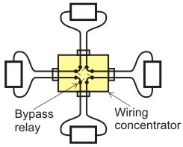
Figure 5.4.2 Star Connected Ring topology

It imposes the reliability in an elegant manner. Although logically the network remains as a ring, physically each station is connected to the wire center with two twisted pairs for
2-way communication. Inside the wire center, bypass relays are used to isolate a broken wire or a faulty station. This Topology is known as Star-Connected Ring.

Frame Format
Token Ring and IEEE 802.5 support two basic frame types: tokens and data/command frames. Tokens are 3 bytes in length and consist of a start delimiter, an access control byte, and an end delimiter. Data/command frames vary in size, depending on the size of the Information field. Data frames carry information for upper-layer protocols, while command frames contain control information and have no data for upper-layer protocols.

Token Frame Fields

Start Delimiter | Access Control | Ending delimiter

Token Frame contains three fields, each of which is 1 byte in length:
        - Start delimiter (1 byte): Alerts each station of the arrival of a token (or data/command frame). This field includes signals that distinguish the byte from the rest of the frame by violating the encoding scheme used elsewhere in the frame.
        - Access-control (1 byte): Contains the Priority field (the most significant 3 bits) and the Reservation field (the least significant 3 bits), as well as a token bit (used to differentiate a token from a data/command frame) and a monitor bit (used by the active monitor to determine whether a frame is circling the ring endlessly).
        - End delimiter (1 byte): Signals the end of the token or data/command frame. This field also contains bits to indicate a damaged frame and identify the frame that is the last in a logical sequence.

Data/Command Frame Fields

Start Delimiter | Access Control | Frame Control | Destination address | Source address | Data | Frame check sequence | End Delimiter | Frame Status

Data/command frames have the same three fields as Token Frames, plus several others. The Data/command frame fields are described below:

- Frame-control byte (1 byte)—Indicates whether the frame contains data or control information. In control frames, this byte specifies the type of control information.
- Destination and source addresses (2-6 bytes)—Consists of two 6-byte address fields that identify the destination and source station addresses.
- Data (up to 4500 bytes)—Indicates that the length of field is limited by the ring token holding time, which defines the maximum time a station can hold the token.
- Frame-check sequence (FCS- 4 byte)—Is filed by the source station with a calculated value dependent on the frame contents. The destination station recalculates the value to determine whether the frame was damaged in transit. If so, the frame is discarded.
- Frame Status (1 byte)—This is the terminating field of a command/data frame. The Frame Status field includes the address-recognized indicator and frame-copied indicator.

